**P720/1**

**Technical & geometrical**

**Drawing**

Paper 1

3 hours

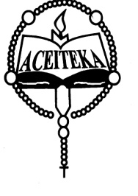

**ACEITEKA JOINT MOCK EXAMINATIONS 2023**

**Uganda Advanced Certificate of Education**

**TECHNICAL& GEOMETRICAL DRAWING**

**Paper 1**

**3 Hours**

**Instructions**

*This question paper consists of two sections* A *and* B*.*

*Answer* ***FIVE questions, not more than three questions are to be taken from each section.***

***All questions carry equal marks.***

*Unless otherwise stated in the question, strictly geometrical methods must be*

*used; but lines parallel, perpendicular or inclined at angles of 30º, 45º, or 60º to other lines, may be drawn without showing construction lines*

*All dimensions of figures are in* ***millimeters****.*